Whiteford, Craig (from Linked In)

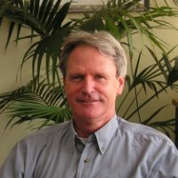

Bachelor of Science (Forestry) ANU 1977-1980. Grad Dip Sciences Communication CQU 1994 – 1996.

Regional Manager - Forest and Public Land Department of Sustainability and Environment 2007 – 2008. Statewide Program Leader - Bioidiversity Programs Dept Sustainabilty and Environment, Victoria 2008 – 2011. Statewide Coordinator - Environment and Water Programs Department of Sustainability and Environment 2011 – .

